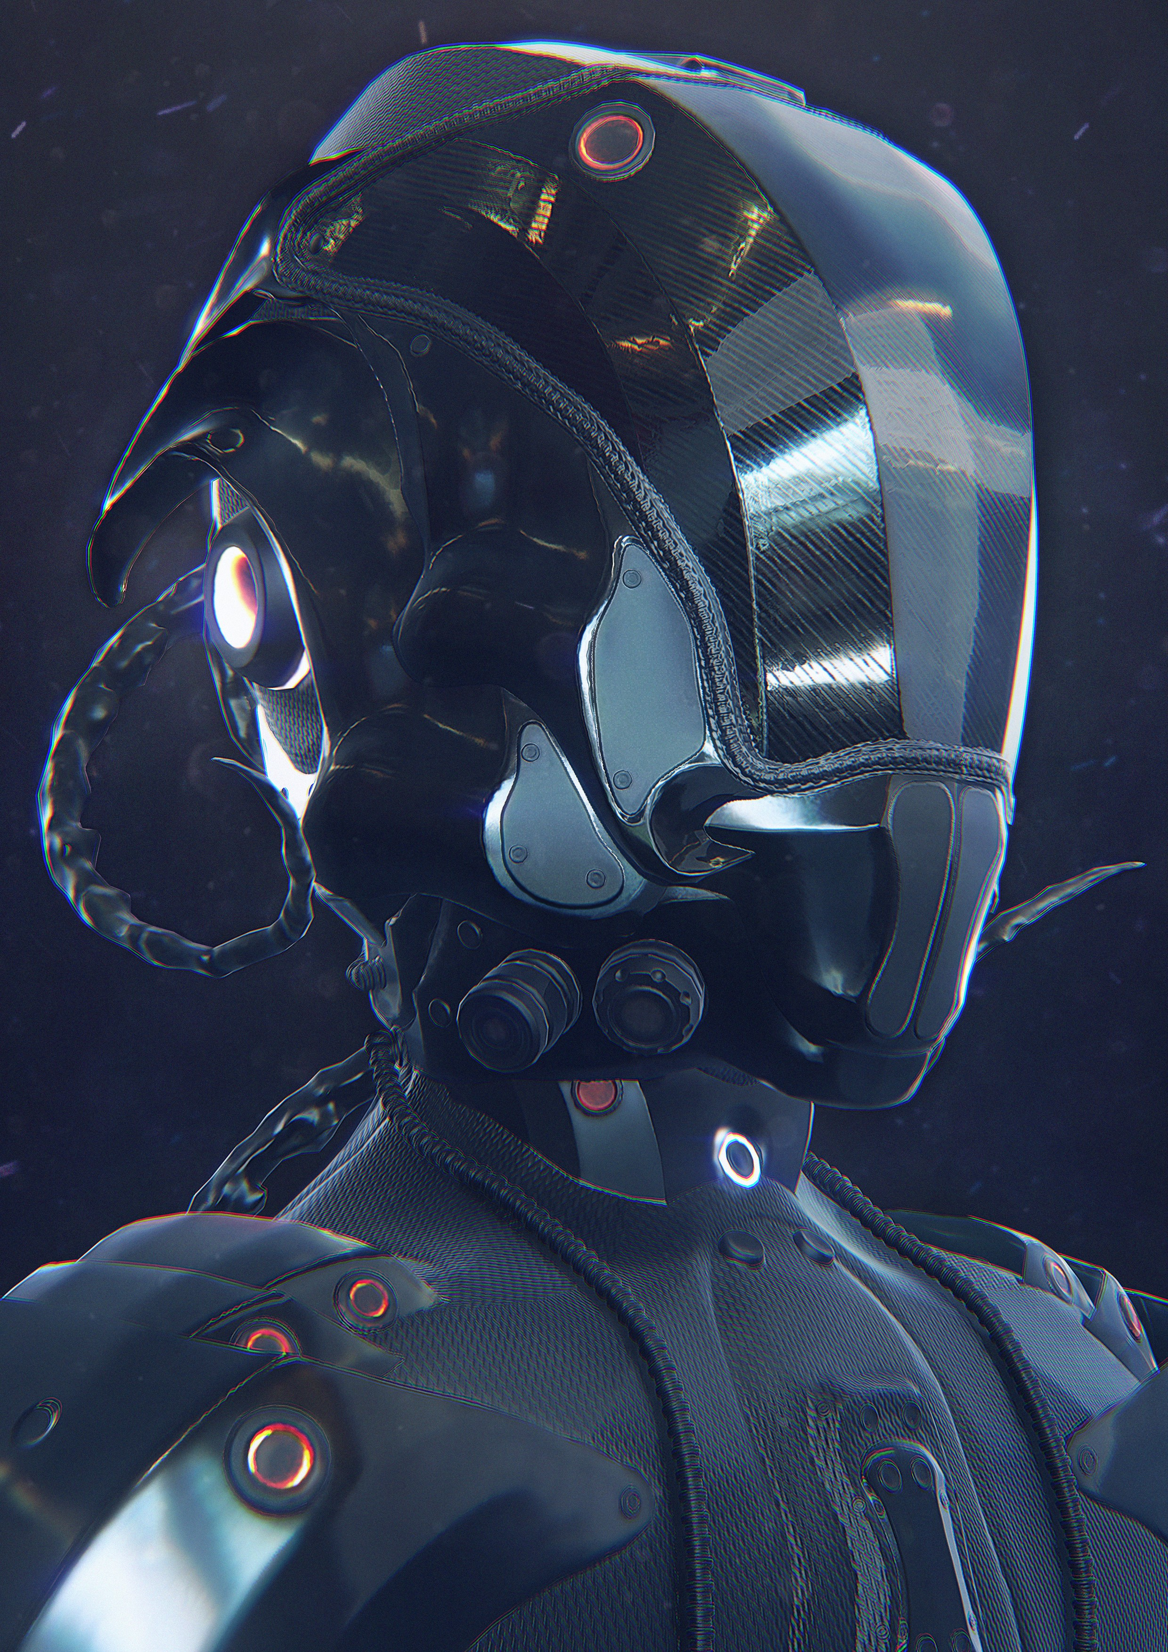

**The**

Light and Matter : The theory of Physically-Based Rendering and Shading.

Technical edit by: Cyrille Damez and Nicolas Wirrmann.(技术 1 - The theory of Physically-Based Rendering and Shading.(1-基于物理的渲染和阴影理论。 )

**Light and Matter.(光和物质。 )**

The theory of Physically-Based Rendering and Shading.(基于物理的渲染和着色理论。 )

Light is a complex phenomenon as it can exhibit properties of both a wave and a particle.(光是一种复杂的现象，因为它可以同时表现出波和粒子的性质。 ) As a result, different models have been created to describe the behavior of light.(因此，已经创建了不同的模型来描述光的行为。 ) As texture artists, we are interested in the Light Ray Model as it describes the interaction of light and matter.(作为纹理艺术家，我们对光线模型感兴趣，因为它描述了光和物质的相互作用。 ) It’s important for us to understand how light rays interact with surface matter because our job is to create textures that describe a surface.(理解光线如何与表面物质相互作用对我们来说很重要，因为我们的工作是创建描述表面的纹理。 ) The textures and materials we author interact with light in our virtual worlds and the more we understand about how light behaves, the better our textures will look.(在我们的虚拟世界中，我们创作的纹理和材料与光相互作用，我们对光的行为了解得越多，我们的纹理就越好看。 )

In this guide, we will discuss the theory behind the physics through which physically-based rendering models are based upon.(在本指南中，我们将讨论基于物理的渲染模型所基于的物理背后的理论。 ) We will start with a light ray and work up to defining the key factors for PBR.(我们将从光线开始工作，确定PBR的关键因素。 )

Light Rays.(光线。 )

The Light Ray Model states that a light ray has the trajectory of a straight line in homogeneous transparent media such as air.(光线模型表示光线在均匀透明介质（如空气）中具有直线的轨迹。 ) The Light Ray Model also says that the ray will behave in a predictable manner when encountering surfaces such as opaque objects or passing through a different medium such as air to water.(光线模型还指出，光线在遇到不透明物体等表面或通过空气到水等不同介质时，其行为是可预测的。 ) This makes it possible to visualize the path the light ray will follow as it moves from a starting point to where it eventually changes into another form of energy such as heat.(这使得当光线从一个起点移动到它最终转变成另一种形式的能量（如热）时，可以可视化光线将遵循的路径。 )

The light ray that hits a surface is called the Incident Ray and the angle that at which it hits is called the Angle of Incidence as shown in figure 01.(击中表面的光线称为入射光，其击中的角度称为入射角，如图01所示。 )

A light ray is incident on a plane interface between two media.(光线入射在两种介质之间平面界面上。 )

When a light ray hits a surface, either or possibly both of these things can happen:.(当光线照射到表面时，这两种情况都可能发生:。 )

1. The light ray is reflected off the surface and travels in a different direction.(光线从表面反射并沿不同的方向传播。 ) It follows the Law of Reflection, which states that the Angle of Reflection is equal to the Angle of Incidence (Reflected Light).(它遵循反射定律，即反射角等于入射角（反射光）。 )
2. The light ray passes from one medium to another in the trajectory of a straight line (Refracted Light).(光线以直线（折射光）的轨迹从一种介质传播到另一种介质。 )

At this point, we can state that light rays split into two directions: reflection and refraction.(在这一点上，我们可以说光线分成两个方向:反射和折射。 ) At the surface, the ray is either reflected or refracted and it can be eventually absorbed by either medium.(在表面上，光线要么被反射，要么被折射，最终可以被任一介质吸收。 ) However, absorption doesn't occur at the surface.(然而，吸附并不发生在表面。 )

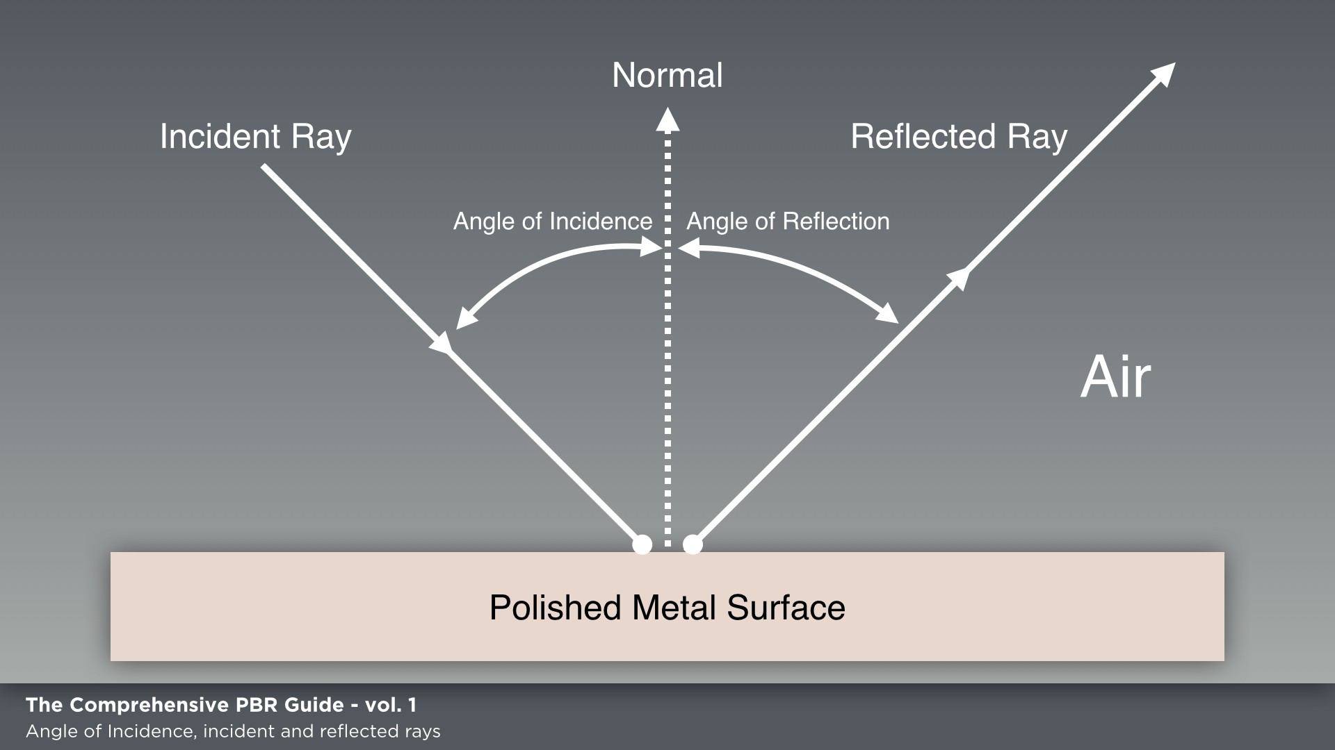

Figure 01.(图01。 )

**Absorption and Scattering (Transparency and Translucency).(吸收和散射（透明和半透明）。 )**

When traveling in an inhomogeneous medium or translucent material, light can be absorbed or scattered:.(当在不均匀介质或半透明材料中传播时，光可以被吸收或散射。 )

1. With absorption, the light intensity decreases as it is changed into another form of energy (usually heat), and its color changes as the amount of light absorbed depends on the wavelength, but the direction of the ray doesn't change.(随着吸收，光强度随着它转变成另一种形式的能量（通常是热）而降低，并且它的颜色随着吸收的光的量取决于波长而变化，但是光线的方向不变。 )
2. With scattering, the ray direction is changed randomly, the amount of deviation depending on the material.(随着散射，光线方向是随机变化的，偏离的量取决于材料。 ) Scattering randomizes light direction but the intensity doesn't change.(散射使光的方向随机化，但强度不变。 ) An ear is a good example.(耳朵就是一个很好的例子。 ) The ear is thin (absorption is low), so you can see the scattered light penetrating out of the back of the ear.(随着散射，光线方向是随机变化的，偏离的量取决于材料。 散射使光的方向随机化，但强度不变。 耳朵就是一个很好的例子。 耳朵很薄（吸收率很低），所以你可以看到散射光从耳朵后面穿透。 ) If there is no scattering and the absorption is low, rays can pass directly through the surface such as with glass.(如果没有散射和吸收低，光线可以直接穿过表面，例如用玻璃。 ) For example, if you are swimming in a pool, which is.(例如，如果您正在游泳池中游泳，这是。 )

hopefully clean, you can open your eyes and see at a fairly good distance through the clear water.(希望明白，你可以打开你的眼睛，并看到在相当好的距离通过清澈的水。 ) However, let’s imagine that same pool hasn't been cleaned in a while and the water is dirty.(然而，让我们想象一下，同一个游泳池已经有一段时间没有被打扫过了，而且水很脏。 ) The dirt particles scatter the light and thus make the clarity of the water much lower.(污垢颗粒散射光线，从而使水的清晰度低得多。 )

The further light travels in such a medium/material, the more it is absorbed and/or scattered.(光在这样的介质/材料中传播的越多，其被吸收和/或散射的越多。 ) Therefore, object thickness plays a large role in how much the light is absorbed or scattered.(因此，物体厚度对光被吸收或散射的程度起着很大的作用。 ) A thickness map can be used to describe object thickness to the shader as shown in figure 02.(厚度图可以用来描述物体的厚度到着色器，如图02所示。 )

Object thickness plays a large role in how much the light is absorbed or scattered.(物体厚度对光被吸收或散射的程度起着很大的作用。 )

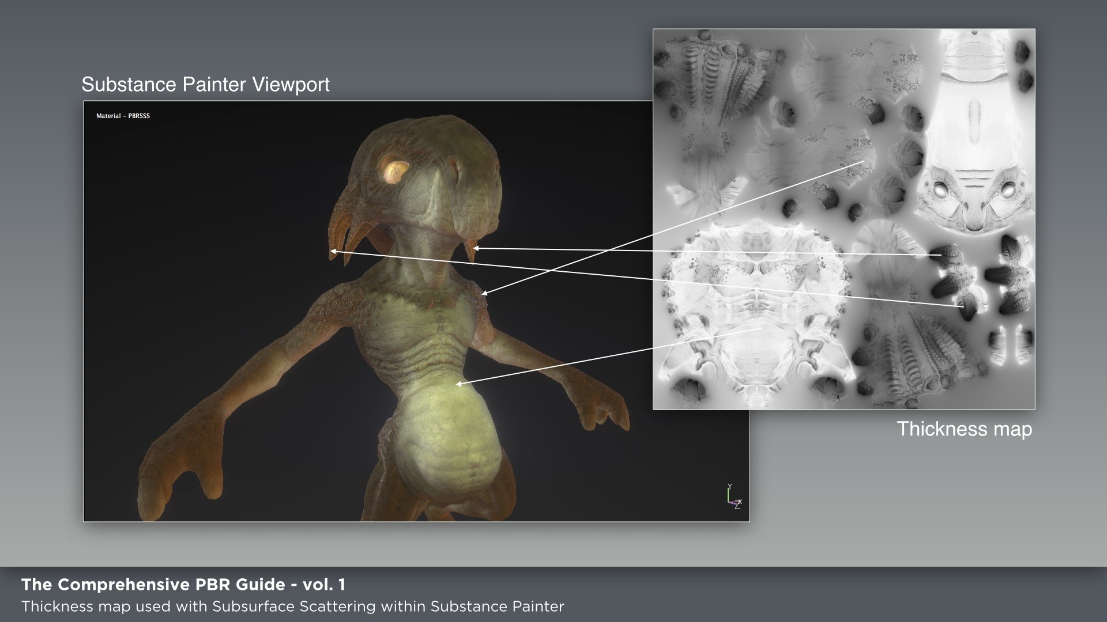

Figure 02.(图02。 )

**Diffuse and Specular Reflection.(漫反射和镜面反射。 )**

Specular reflection is light that has been reflected at the surface, as we discussed above in the Light Ray section.(镜面反射是已经在表面反射的光，如我们在上面的光线部分中所讨论的。 ) The light ray is reflected off the surface and travels in a different direction.(光线从表面反射并沿不同的方向传播。 ) It follows the Law of Reflection, which states that on a perfectly planar surface the Angle of Reflection is equal to the Angle of Incidence.(镜面反射是已经在表面反射的光，如我们在上面的光线部分中所讨论的。 光线从表面反射并沿不同的方向传播。 它遵循反射定律，即在一个完美的平面上，反射角等于入射角。 ) However, it is important to note that most surfaces are irregular and that the reflected direction will therefore vary randomly based on the surface roughness.(然而，重要的是要注意，大多数表面是不规则的，因此反射方向将根据表面粗糙度随机变化。 ) This changes light direction, but the light intensity remains constant.(这改变了光的方向，但是光的强度保持不变。 )

.(好吧。 )

Rougher surfaces will have larger and dimmer looking highlights.(粗糙的表面会有更大更暗的亮点。 ) Smoother surfaces will keep specular reflections focused, which can appear to look brighter or more intense when looked at from the proper angle.(更光滑的表面将保持镜面反射的聚焦，当从适当的角度观察时，镜面反射看起来更明亮或更强烈。 )

However, the same total amount of light is reflected in both cases as shown in figure 03.(然而，如图03所示，在这两种情况下反射的光总量相同。 )

Diffuse reflection is light that has been refracted.(漫反射是被折射的光。 ) The light ray passes from one medium to another and is scattered multiple times inside the object.(光线从一种介质传播到另一种介质，并在物体内部多次散射。 ) Then it is.(那就是了。 )

refracted again out of the object making its way back to the original medium at approximately the same point where it went through the first time as shown in figure 04.(再次折射出物体，使其在第一次经过的点处返回到原始介质，如图04所示。 )

Diffuse materials are fairly absorbent, meaning that if the refracted light travels for too long in that material, it has a good chance of being completely absorbed.(漫射材料是相当有吸收性的，这意味着如果折射的光在该材料中传播太长时间，它很有可能被完全吸收。 ) This means that if the light ever comes out of that material, it has probably not traveled very far from the point of entry.(这意味着，如果光曾经从那个物质中射出，它可能并没有从进入点传播得很远。 )

That's why the distance between the entry and exit points can be neglected.(这就是为什么入境点和出境点之间的距离可以忽略不计的原因。 ) The Lambertian model, which is usually used for diffuse reflection in a traditional shading.(Lambertian模型，通常用于传统阴影中的漫反射。 )

sense, does not take surface roughness into account, but there are diffuse reflection models that do such as Oren- Nayar.(表面粗糙度不考虑，但有漫反射模型，如Oren-Nayar。 )

Materials that have both high scattering but low absorption are sometimes referred to as "participating media" or "translucent materials".(同时具有高散射和低吸收的材料有时被称为“参与介质”或“半透明材料”。 ) Examples of these are smoke, milk, skin, jade and marble.(例如烟、牛奶、皮肤、玉石和大理石。 ) Rendering of the latter three may be possible with the additional modeling of subsurface scattering where the difference between the ingoing and outgoing point of the light ray is no longer neglected.(后三者的渲染可以通过对次表面散射的附加建模来实现，其中光线的入射点和出射点之间的差异不再被忽略。 ) Accurate rendering of medium with highly varying and very low scattering and absorption like.(同时具有高散射和低吸收的材料有时被称为“参与介质”或“半透明材料”。 例如烟、牛奶、皮肤、玉石和大理石。 后三者的渲染可以通过对次表面散射的附加建模来实现，其中光线的入射点和出射点之间的差异不再被忽略。 高变化、低散射、低吸收类介质的精确绘制。 )

smoke or fog may require even more expensive methods such as Monte Carlo simulations.(烟或雾可能需要更昂贵的方法，如蒙特卡罗模拟。 )

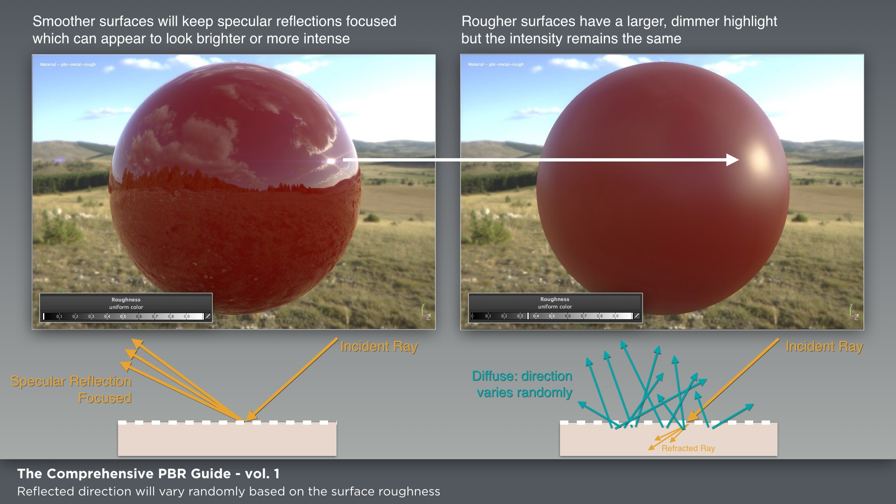

Rougher surfaces will have larger and dimmer looking highlights.(粗糙的表面会有更大更暗的亮点。 )

Figure 03.(图03。 )

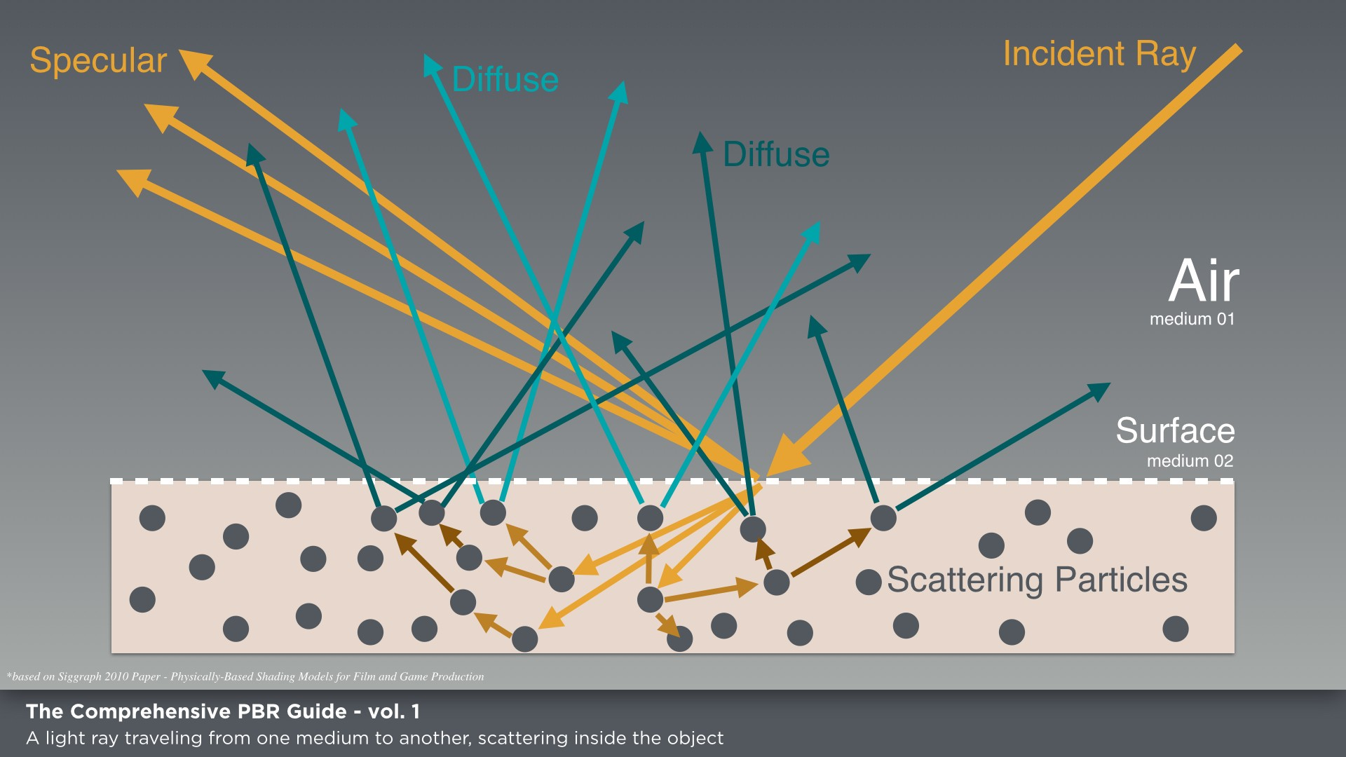

**Figure 04.(图04。 )**

Microfacet Theory.(微面理论 )

In theory, both diffuse and specular reflection are dependent on the surface irregularities where the light rays intersect.(理论上，漫反射和镜面反射都依赖于光线相交处的表面不规则性。 ) In practice though, the effect of roughness on diffuse reflection is much less visible because of the scattering happening inside the material.(但在实际应用中，由于材料内部发生散射，粗糙度对漫反射的影响要小得多。 ) As a result, the outgoing direction of the ray is fairly independent of surface roughness and the incident direction.(结果，射线的出射方向与表面粗糙度和入射方向相当独立。 ) The most common model for diffuse reflection (Lambertian) completely neglects it.(最常见的漫反射模型（Lambertian）完全忽略了这一点。 )

In this document, we have referred to these surface irregularities as surface roughness.(在本文中，我们将这些表面不平整称为表面粗糙度。 ) Actually, it is often referred to by several names.(实际上，它经常被称为几个名字。 )

.(好吧。 )

Figure 05.(图05。 )

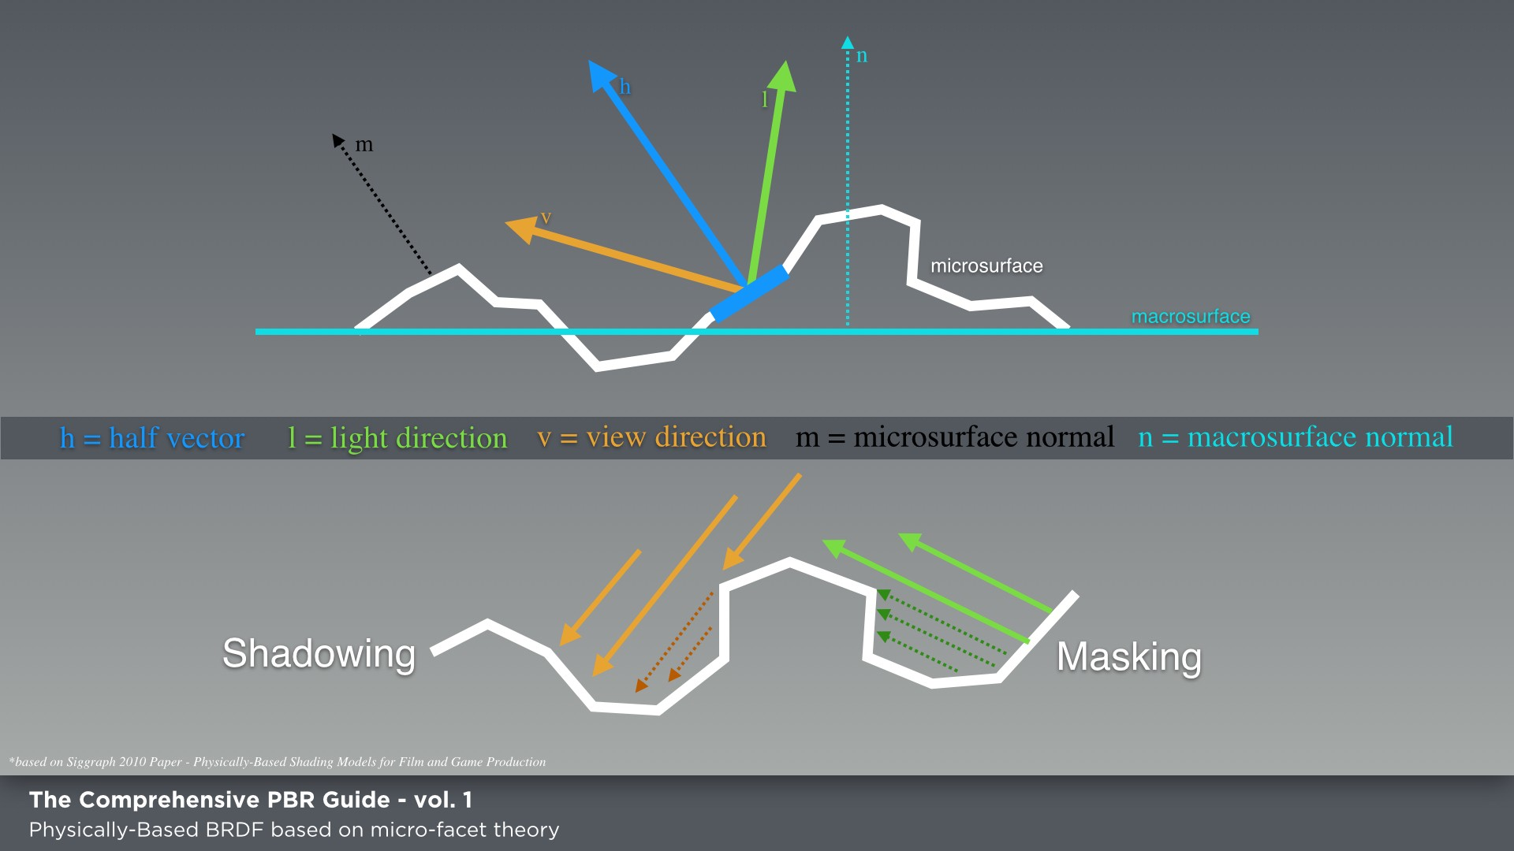

.(好吧。 )

the microsurface normal and the half normal are equal.(微表面法线和半法线相等。 )

such as roughness, smoothness, glossiness or micro- surface, depending on the PBR workflow in use, but they describe the same aspect of a surface, which is sub-texel geometric detail.(例如粗糙度、光滑度、光泽度或微表面，这取决于使用的PBR工作流，但它们描述的是表面的相同方面，即亚纹理几何细节。 )

These surface irregularities are authored in the roughness or glossiness map depending on the workflow you are using.(根据您使用的工作流，这些表面不规则性是在粗糙度或光泽度映射中创建的。 ) A physically-based BRDF is based on the microfacet theory which supposes that a surface is composed of small-scaled planar detail surfaces of varying orientation called microfacets.(基于物理的BRDF是基于微刻面理论的，该理论假设一个表面由称为微刻面的不同取向的小尺度平面细节表面组成。 ) Each of these small planes reflects light in a single direction based on its normal as shown in figure 05.(这些小平面中的每一个根据其法线在单个方向上反射光，如图05所示。 )

Micro-facets whose surface normal is oriented exactly halfway between the light direction and view direction will reflect visible light.(表面法线恰好在光的方向和观察方向中间的微平面将反射可见光。 ) However, not all microfacets where.(然而，并不是所有的微面。 )

will contribute as some will be blocked by shadowing (light direction) or masking (view direction) as is illustrated in figure 05.(如图05所示，阴影（光线方向）或遮蔽（视图方向）会阻挡某些目标，因此会产生影响。 )

The surface irregularities at a microscopic level cause light diffusion.(在微观水平上的表面不规则性引起光扩散。 ) For example, blurred reflections are due to scattered light rays.(例如，模糊的反射是由于散射光线。 ) The rays are not reflected in parallel so we perceive the specular reflection as blurred as shown in figure 06.(在微观水平上的表面不规则性引起光扩散。 例如，模糊的反射是由于散射光线。 光线不平行反射，因此我们感觉镜面反射模糊，如图06所示。 )

The surface irregularities at a microscopic level cause light diffusion.(在微观水平上的表面不规则性引起光扩散。 )

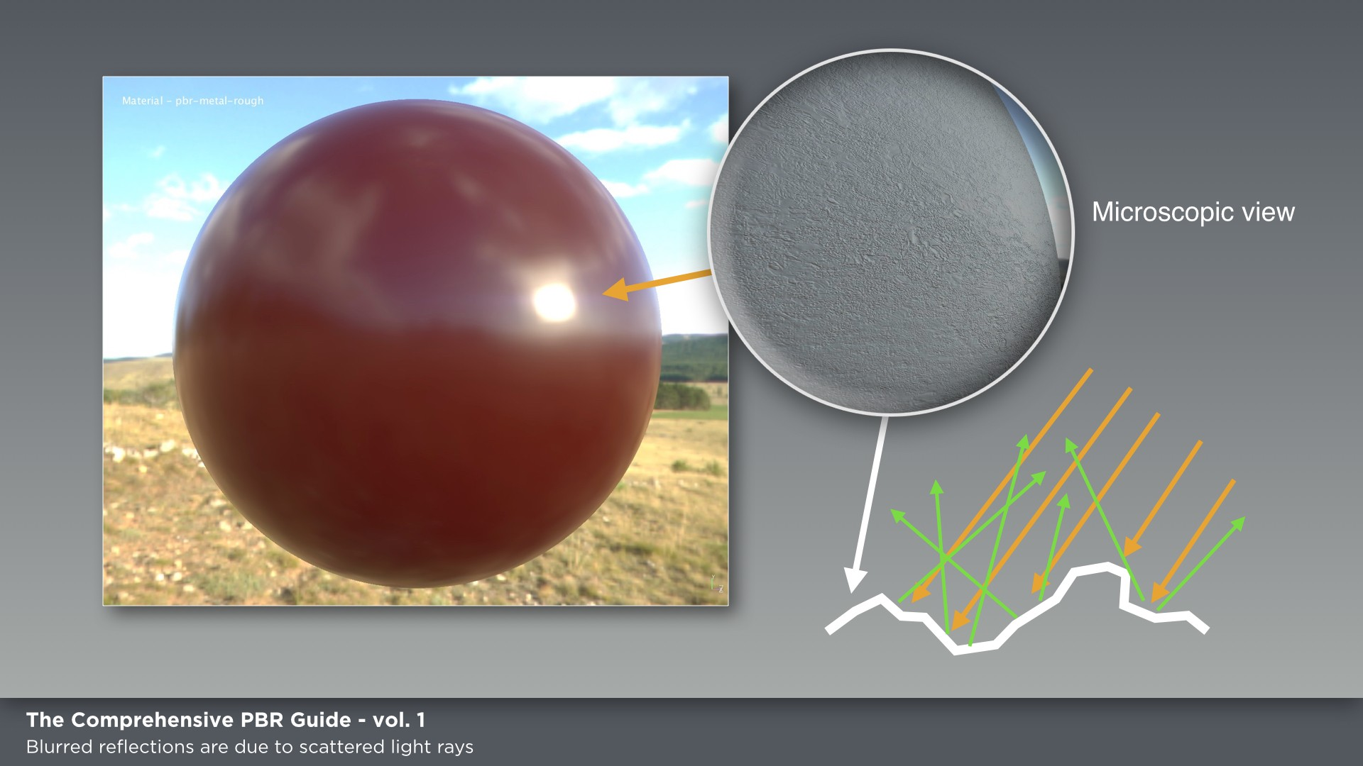

Figure 06.(图06。 )

**Color.(颜色。 )**

The color of a surface (which is to say the color that we see) is due to which wavelengths are emitted by the light source, which are absorbed by the object and which others are reflected both specularly and diffusely.(表面的颜色（也就是我们所看到的颜色）是由于光源发出的波长，被物体吸收的波长，以及其他的波长被镜面和漫反射的波长。 )

The remaining reflected wavelengths are what we see as color.(剩下的反射波长就是我们所看到的颜色。 )

For example, the skin of an apple mostly reflects red light.(例如，苹果皮主要反射红光。 ) Only the red wavelengths are scattered back outside the apple skin and the others are.(只有红色的波长被散射回苹果皮外，其他的波长则被散射回苹果皮外。 )

.(好吧。 )

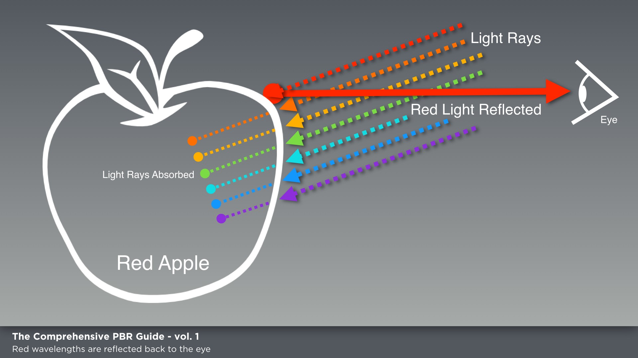

Figure 07.(图07。 )

absorbed by it as shown in figure 07.(被它吸收，如图07所示。 )

It also has bright specular highlights the same color as the light source because with materials like the skin of an apple that are not electrical conductors (dielectrics), specular reflection is almost independent of wavelength.(它还具有与光源相同颜色的明亮的镜面高光，因为对于像苹果皮这样不是电导体（电介质）的材料，镜面反射几乎与波长无关。 ) Therefore, for such materials the specular reflection is never colored.(因此，对于这样的材料，镜面反射从不着色。 ) We will discuss more about the different type of materials (metals and dielectrics) in later sections.(它还具有与光源相同颜色的明亮的镜面高光，因为对于像苹果皮这样不是电导体（电介质）的材料，镜面反射几乎与波长无关。 因此，对于这样的材料，镜面反射从不着色。 我们将在后面的章节中更多地讨论不同类型的材料（金属和电介质）。 )

.(好吧。 )

Substance PBR shaders use the GGX microfacet distribution.(物质PBR着色器使用GGX微面分布。 )

**BRDF.(BRDF。 )**

A Bidirectional Reflectance Distribution Function (BRDF) simply put is a function that describes the reflectance properties of a surface.(简单地说，双向反射分布函数(BRDF)是描述表面反射特性的函数。 ) In computer graphics, there are different BRDF models some of which are not physically plausible.(在计算机图形学中，有不同的BRDF模型，其中一些模型在物理上是不可信的。 ) For a BRDF to be physically plausible, it must be energy conserving and exhibit reciprocity.(为了使BRDF在物理上合理，它必须是节能的，并表现出互惠性。 ) For reciprocity, I am referring to the Helmholtz Reciprocity principle, which states that incoming and outgoing light.(对于互惠，我指的是亥姆霍兹互惠原则，它规定了光的入射和出射。 )

.(好吧。 )

rays can be considered as reversals of each other without affecting the outcome of the BRDF.(射线可以被认为是彼此的反转而不影响BRDF的结果。 )

The BRDF used by Substance's PBR shaders is based on Disney's "principled" reflectance model, which is based on the GGX microfacet distribution.(物质的PBR着色器使用的BRDF基于迪士尼的“原则性”反射模型，该模型基于GGX微面分布。 ) GGX provides one of the better solutions in terms of specular distribution in that it has a shorter peak in the highlight and a longer tail in the.(在镜面分布方面，GGx提供了更好的解决方案之一，因为它在高光中具有更短的峰值，在中具有更长的尾部。 )

falloff, which is to say that it looks more realistic as shown in figure 08.(falloff，也就是说，它看起来更逼真，如图08所示。 )

Object GGX provides one of the better solutions in terms of specular distribution.(对象GGX在镜面分布方面提供了更好的解决方案之一。 )

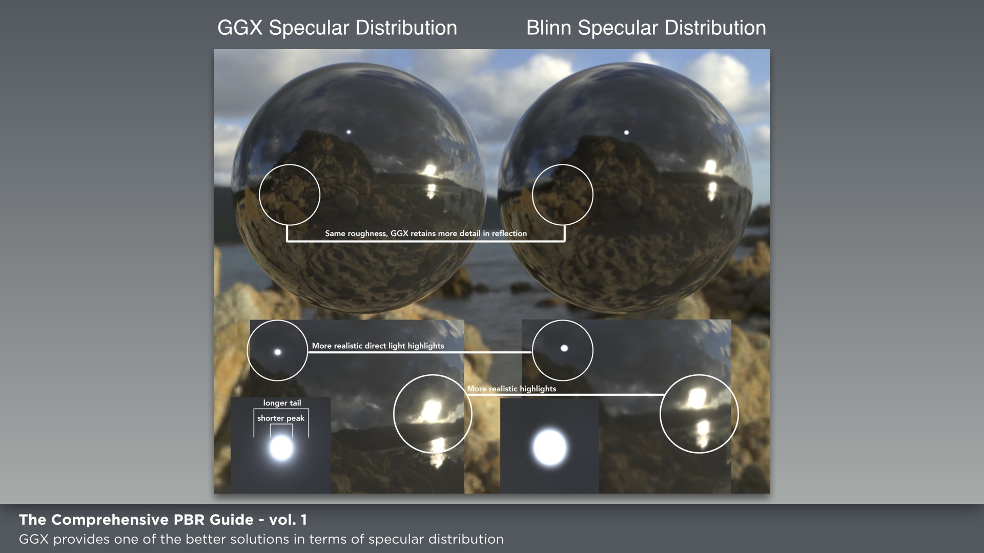

Figure 08.(图08。 )

**Energy Conservation.(节能。 )**

Energy Conservation plays a vital role in physically-based rendering solutions.(节能在基于物理的渲染解决方案中起着至关重要的作用。 ) It states that the total amount of light re-emitted by a surface (reflected and scattered back) is less than the total amount it received.(它指出，一个表面重新发射（反射和散射回来）的光的总量小于它接收到的光的总量。 ) In other words, the light reflected off the surface will never be more intense than it was before it hit the surface.(换句话说，从表面反射的光将永远不会比它到达表面之前更强烈。 ) As artists, we don't have to worry about controlling Energy Conservation.(作为艺术家，我们不必担心控制能源节约。 ) This is one of the nice aspects of PBR in that energy conservation is always enforced by the shader.(这是PBR的一个很好的方面，因为能量守恒总是通过着色器来实现的。 ) It’s part of the physically-based model and it allows us to focus more on art rather than physics.(这是基于物理的模型的一部分，它允许我们更多地关注艺术而不是物理。 )

Fresnel Effect.(菲涅耳效应 )

The Fresnel reflection factor also plays a vital role in physically-based shading as a coefficient of the BRDF.(菲涅耳反射因子作为BRDF的一个系数，在基于物理的阴影中也起着至关重要的作用。 ) The Fresnel Effect as observed by French physicist Augustin-Jean Fresnel states that the amount of light you see reflected from a surface depends on the viewing angle at which you perceive it.(法国物理学家Augustin-Jean Fresnel观察到的菲涅耳效应表明，你看到的从表面反射的光的量取决于你看到它的视角。 )

For example, think of a pool of water.(例如，想象一个水池。 ) If you look straight down, perpendicular to the water surface, you can see down to the bottom.(如果你往下看，垂直于水面，你可以看到下面。 ) Viewing the water surface in this manner would be at zero degrees or normal incidence, normal being the surface normal.(以这种方式观察水面将处于零度或法向入射角度，法向为水面法向。 ) Now, if you look at the pool of water at a grazing incidence, more parallel to the water surface, you will see that the specular reflections on the water surface become more intense and you may not be able to see below the surface of the water at all.(现在，如果你观察一个与水面平行的掠入射水池，你会看到水面上的镜面反射变得更加强烈，你可能根本看不到水面以下的情况。 )

Fresnel is not something that we control in PBR as we did in traditional shading.(菲涅耳不是我们在PBR中控制的东西，因为我们在传统的阴影。 ) Again, this is another physics aspect that is handled for us by the PBR shader.(同样，这是另一个物理方面，是为我们处理的PBR着色器。 ) When it comes to viewing a surface at a grazing incidence, all smoothed surfaces will become a nearly 100% reflector at a 90 degree angle of incidence.(当在掠入射下观察表面时，所有光滑表面在90度入射角下将成为近100%的反射器。 )

For rough surfaces, reflectance will become increasingly specular but we won't approach 100% specular reflection.(对于粗糙表面，反射率将变得越来越镜面，但我们不会接近100%镜面反射。 ) What matters then is the angle between the normal of each microfacet and the light, not the angle between the normal of the "macrosurface" and the light.(那么重要的是每个微面的法线与光线之间的角度，而不是“宏观表面”的法线与光线之间的角度。 ) Because the light rays are dispersed into different directions, the reflection appears softer or dimmer.(由于光线分散到不同的方向，反射显得更柔和或更暗。 ) What you get at a macroscopic level is a bit like the average of all the Fresnel effect you would have for the microfacets.(在宏观层面上得到的结果有点像所有菲涅耳效应的平均值。 )

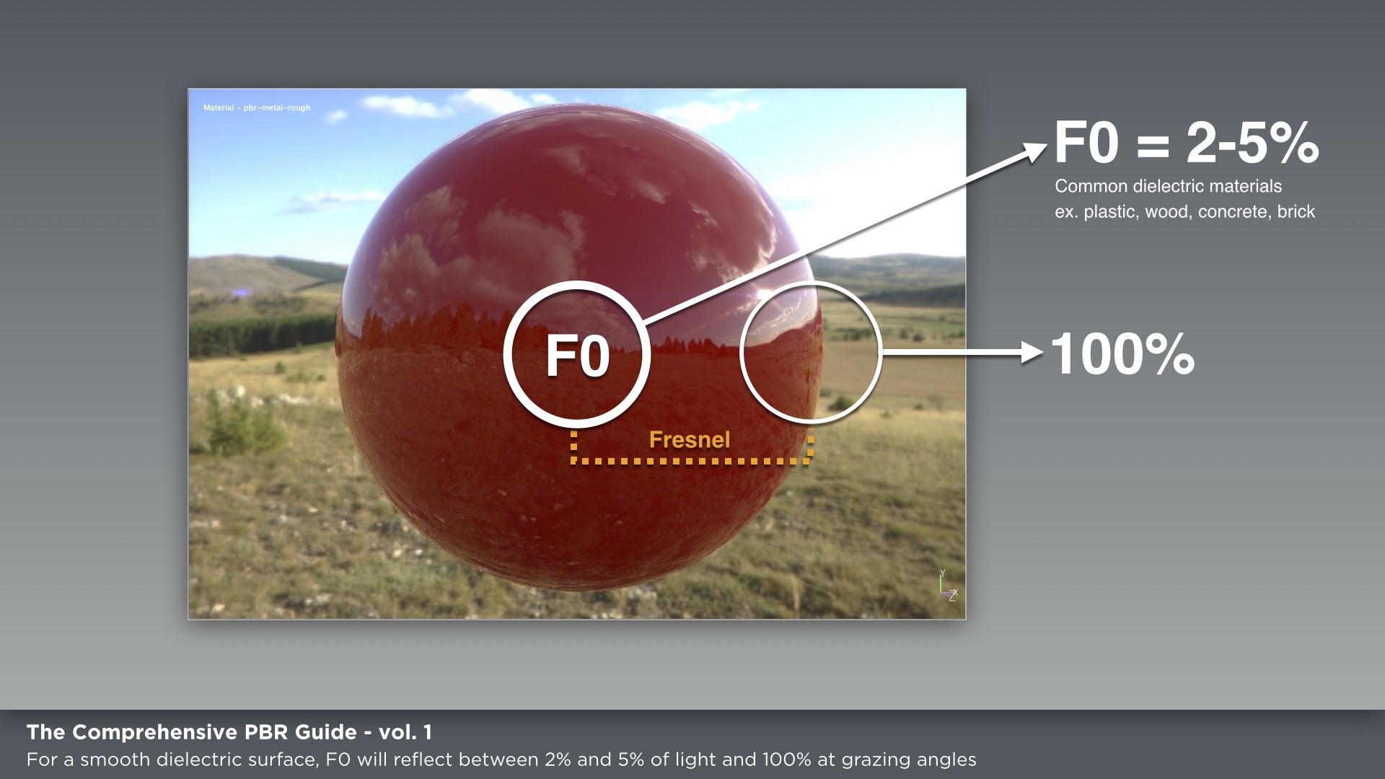

Figure 09.(图09。 )

**For rough surfaces, reflectance will become increasingly specular but we won't approach 100% specular reflection.(对于粗糙表面，反射率将变得越来越镜面，但我们不会接近100%镜面反射。 )**

F0 (Fresnel Reflectance at 0 Degrees).(F0（0度菲涅耳反射率）。 )

When light hits a surface straight on or perpendicularly (0 degree angle), there is a percentage of that light that is reflected back as specular.(当光线直射或垂直（0度角）射入表面时，有一定百分比的光线会反射回来成为镜面。 ) Using the Index of Refraction (IOR) for a surface, you can derive the amount that is reflected back and this is referred to as.(使用曲面的折射率(IOR)，您可以导出反射回来的量，这称为。 )

F0 (Fresnel 0) as shown in figure 09.(F0（Fresnel0），如图09所示。 ) The amount of light that is refracted into the surface is referred to a 1-F0.(F0（Fresnel0），如图09所示。 折射到表面的光量称为1-f0。 )

The F0 range for most common dielectrics will be from 0.(大多数常见电介质的F0范围为0。 )02 - 0.(02-0。 )05 and for conductors the F0 range will be 0.(对于导体，F0范围为0。 )5-1.(5-1。 )0.(0。 ) Thus, the reflectivity of a surface is determined by the refractive index as shown in the following equation from Sebastien Lagarde's "Feeding a Physically-based Shading.(因此，一个表面的反射率是由折射率决定的，如下图所示，折射率取自Sebastien Lagarde的“feeding a physically-based shading”。 )

Model" blog post as shown in figure 10.(模型“博客文章，如图10所示。 )

It is the F0 reflectance value that we are concerned with in regards to authoring our textures.(这是F0反射率值，我们关心的创作我们的纹理。 ) Non-metals (dielectrics/insulators) will have a greyscale value and metals (conductors).(这是F0反射率值，我们关心的创作我们的纹理。 非金属（电介质/绝缘体）将具有灰度值和金属（导体）。 )

.(好吧。 )

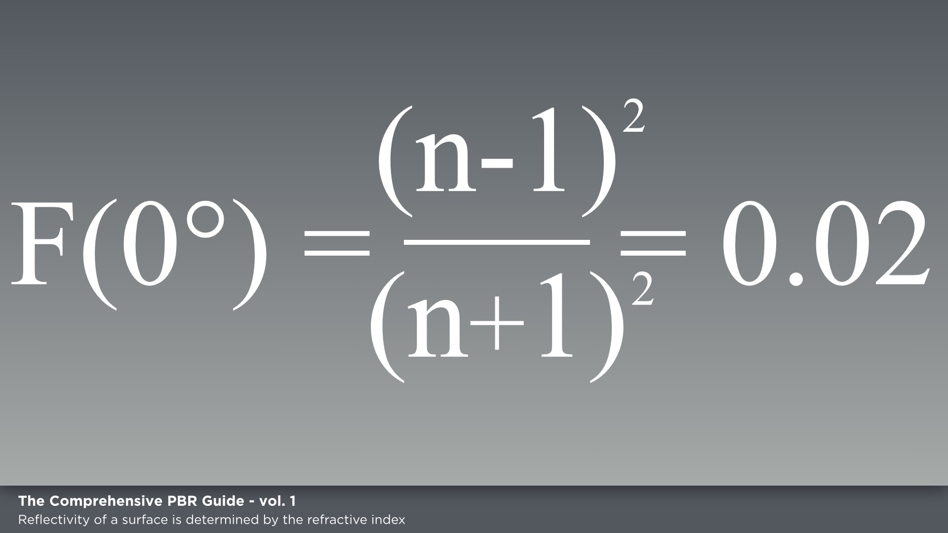

roughness the actual changes in value can be hard to see.(粗糙度值的实际变化可能很难看到。 ) However, there is a difference in the values.(但是，这些值存在差异。 ) In figure 11, you can see a chart that shows the F0 ranges for both metal and non-metal materials.(在图11中，您可以看到一个图表，其中显示了金属和非金属材料的F0范围。 )

will have an RGB value.(将具有RGB值。 ) With regards to PBR and from an artistic interpretation of reflectance, we can state that for a.(关于PBR，从反射率的艺术解释，我们可以说，对于一个。 )

Figure 10.(图10。 )

.(好吧。 )

Notice that the ranges for non-metals do not deviate.(请注意，非金属的范围不会偏离。 )

common smooth dielectric surface, F0 will reflect between 2% and 5% of light and 100% at grazing angles as was shown in figure 09.(常见的光滑介电表面，f0将反射2%至5%的光，并在掠入射角下反射100%，如图09所示。 )

The dielectric (non-metal) reflectance values don't actually change very drastically.(介质（非金属）反射率值实际上变化不大。 ) In fact, when altered by.(事实上，当被改变的时候。 )

from each other drastically.(完全不同。 ) Gemstones are an exception as they have higher values.(宝石是一个例外，因为它们有更高的价值。 ) We will discuss F0 as it specifically relates to conductors and insulators a bit later.(稍后我们将讨论F0，因为它与导体和绝缘体具体相关。 )

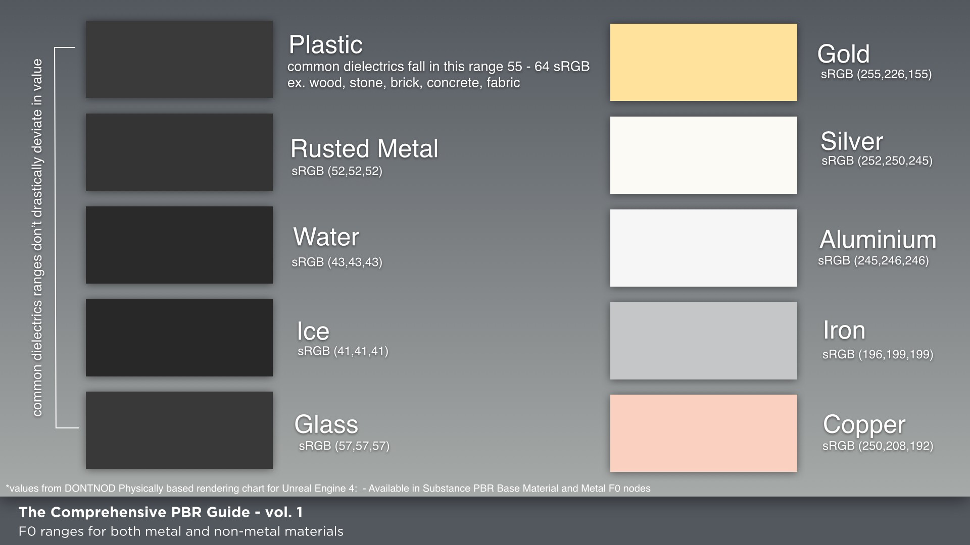

Figure 11.(图11。 )

**Conductors and Insulators (Metals and Non-Metals).(导体和绝缘体（金属和非金属）。 )**

When creating materials for PBR, I find it helpful to think in terms of metal or non-metal.(当为PBR创造材料时，我发现从金属或非金属的角度来思考是有帮助的。 ) I simply ask myself if the surface is metal or not.(我只是问自己表面是不是金属。 ) If it is, I follow one set of guidelines and if it’s not, I follow another.(如果是，我遵循一套准则，如果不是，我遵循另一套准则。 ) This can be a rather simplistic approach as some materials may not fall into these categories such as metalloids, but in the overall process of creating materials, distinguishing between metal and non-metal is a good approach and metalloids are an exception.(这可能是一种相当简单的方法，因为有些材料可能不属于这些类别，例如类金属，但在整个材料创造过程中，区分金属和非金属是一种很好的方法，类金属是一种例外。 ) To set up guidelines for materials, we first must understand what we are trying to create.(要制定材料的指导方针，首先我们必须了解我们正在努力创造什么。 ) With PBR, we can look at the properties of metals (conductors) and non-metals (insulators) to derive this set of guidelines.(使用PBR，我们可以查看金属（导体）和非金属（绝缘体）的属性以导出这组准则。 )

Refracted light is absorbed, the color tint of metals come from the reflected light and thus in our maps, we don't give metals a diffuse color.(折射光被吸收，金属的色调来自反射光，因此在我们的地图上，我们不给金属一个漫射的颜色。 )

Metals.(金属。 )

Metals (conductors) are good conductors of heat and electricity.(金属（导体）是热和电的好导体。 ) Simply put, the electric field in conducting metals is zero and when an incoming light wave made of electric and magnetic fields hits the surface, it is partially reflected and all the refracted.(简单地说，导电金属中的电场为零，当由电场和磁场组成的入射光波击中表面时，它被部分反射，所有的光波都被折射。 )

light is absorbed.(光被吸收了。 ) The reflectance value for polished metal is going to be high at a range of about 70-100% reflective as shown in figure 12.(如图12所示，抛光金属的反射率值在70-100%的范围内会很高。 )

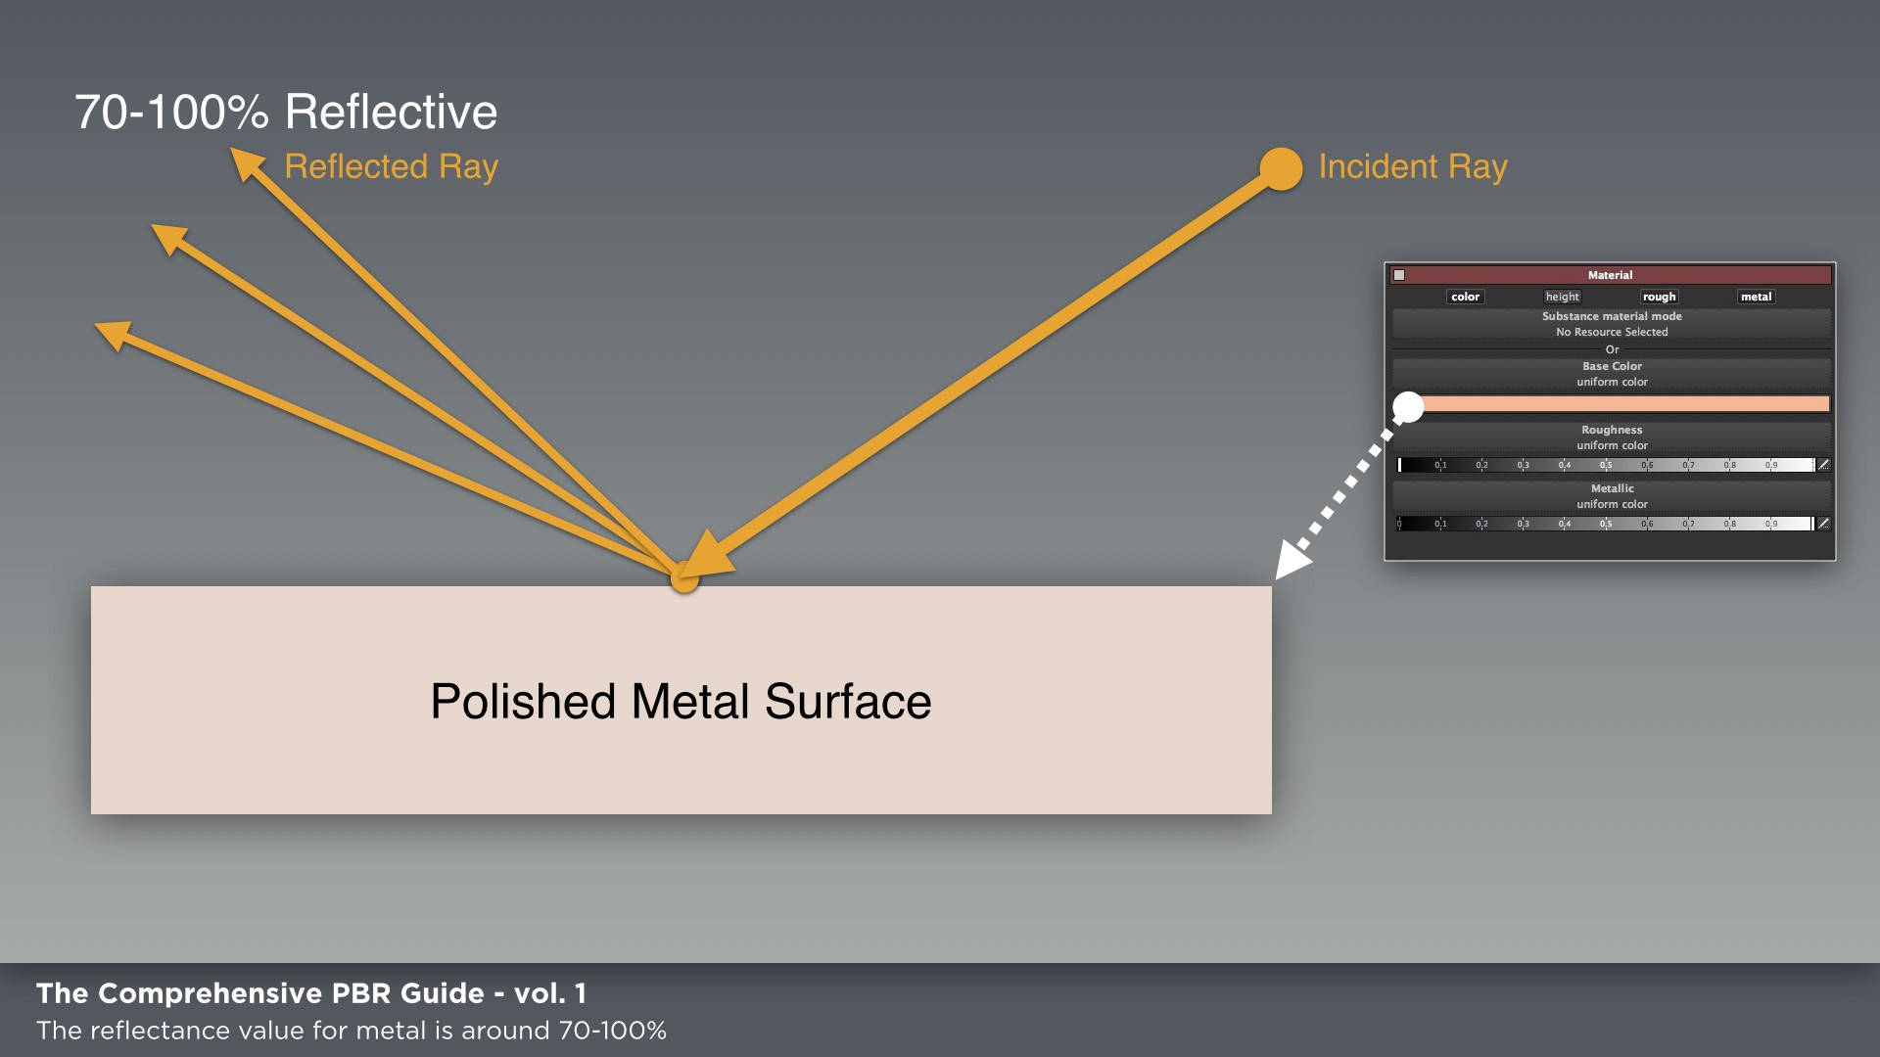

Some metals absorb light at different wavelengths.(有些金属吸收不同波长的光。 ) For example, gold absorbs blue light at the high-frequency end of the visible spectrum so it appears yellow as a result.(有些金属吸收不同波长的光。 例如，金在可见光光谱的高频端吸收蓝光，因此它呈现黄色。 ) However, since the refracted light is absorbed, the color tint of metals come from the reflected light and thus in our maps, we don't give metals a diffuse color.(可见光谱，因此它看起来是黄色的。 然而，由于折射光被吸收，金属的色调来自反射光，因此在我们的地图中，我们不给金属一个漫射的颜色。 ) For example, in the specular/ gloss workflow, raw metal is set to black in the diffuse map and.(颜色。 例如，在镜面/光泽工作流程中，原金属在漫射图中被设置为黑色。 )

.(好吧。 )

top of the raw metal.(生铁的顶端。 ) Only the raw metal exposed from chipped away paint is treated as metal.(只有从剥落的油漆中露出来的原金属才被当作金属处理。 ) The same goes for dirt on the metal or any matter that obscures the raw metal.(金属上的污垢或任何遮蔽原金属的物质也是如此。 )

the reflectance value is a tinted.(反射率值是有色的。 )

color value in the specular map.(镜面图中的颜色值。 ) With metals, the reflectance.(金属的反射率。 )

Figure 12.(图12。 )

value will be RGB and can be tinted.(值将为RGB并可以着色。 ) Since we are working within a physically-based model, we need to use real-world measured values for the metal reflectance in our maps.(由于我们是在一个基于物理的模型中工作，我们需要在地图中使用实际测量的金属反射率值。 )

Another important aspect with metals in terms of texturing is that metal can corrode.(金属在织构方面的另一个重要方面是金属可以腐蚀。 ) This means that weathering elements can play a large role in the reflective state of metal.(这意味着风化元素可以在金属的反射状态中起到很大的作用。 ) If the metal rusts for example, this changes the reflective state of the metal and the corroded areas are then treated as a dielectric material as shown in figure 13.(金属在织构方面的另一个重要方面是金属可以腐蚀。 这意味着风化元素可以在金属的反射状态中起到很大的作用。 例如，如果金属生锈，则会改变金属的反射状态，然后将腐蚀区域作为介电材料处理，如图13所示。 )

Also, metal that is painted is not treated like a metal but rather a dielectric as well.(同样，被涂漆的金属也不像金属那样被处理，而是像电介质一样被处理。 ) The paint acts as a layer on.(油漆在上面起一层作用。 )

I stated above that I always ask myself if a material is a metal or not.(我在上面说过，我总是问自己一种材料是不是金属。 ) However, to be more precise, the question should also inquire the state of the metal such as is it painted, rusted or covered in dirt/grease.(然而，更确切地说，问题还应询问金属的状态，例如金属是否被涂漆、生锈或被污垢/油脂覆盖。 ) The material will be treated as dielectric if it is not raw metal and there could be some blending between metal and non-metal depending on the weathering.(我在上面说过，我总是问自己一种材料是不是金属。 然而，更确切地说，问题还应询问金属的状态，例如金属是否被涂漆、生锈或被污垢/油脂覆盖。 如果材料不是原金属，则将其作为电介质处理，并且金属和非金属之间可能存在一些混合，这取决于风化作用。 )

Weathering elements can play a large role in the reflective state of metal.(风化元素在金属的反射状态中起着很大的作用。 )

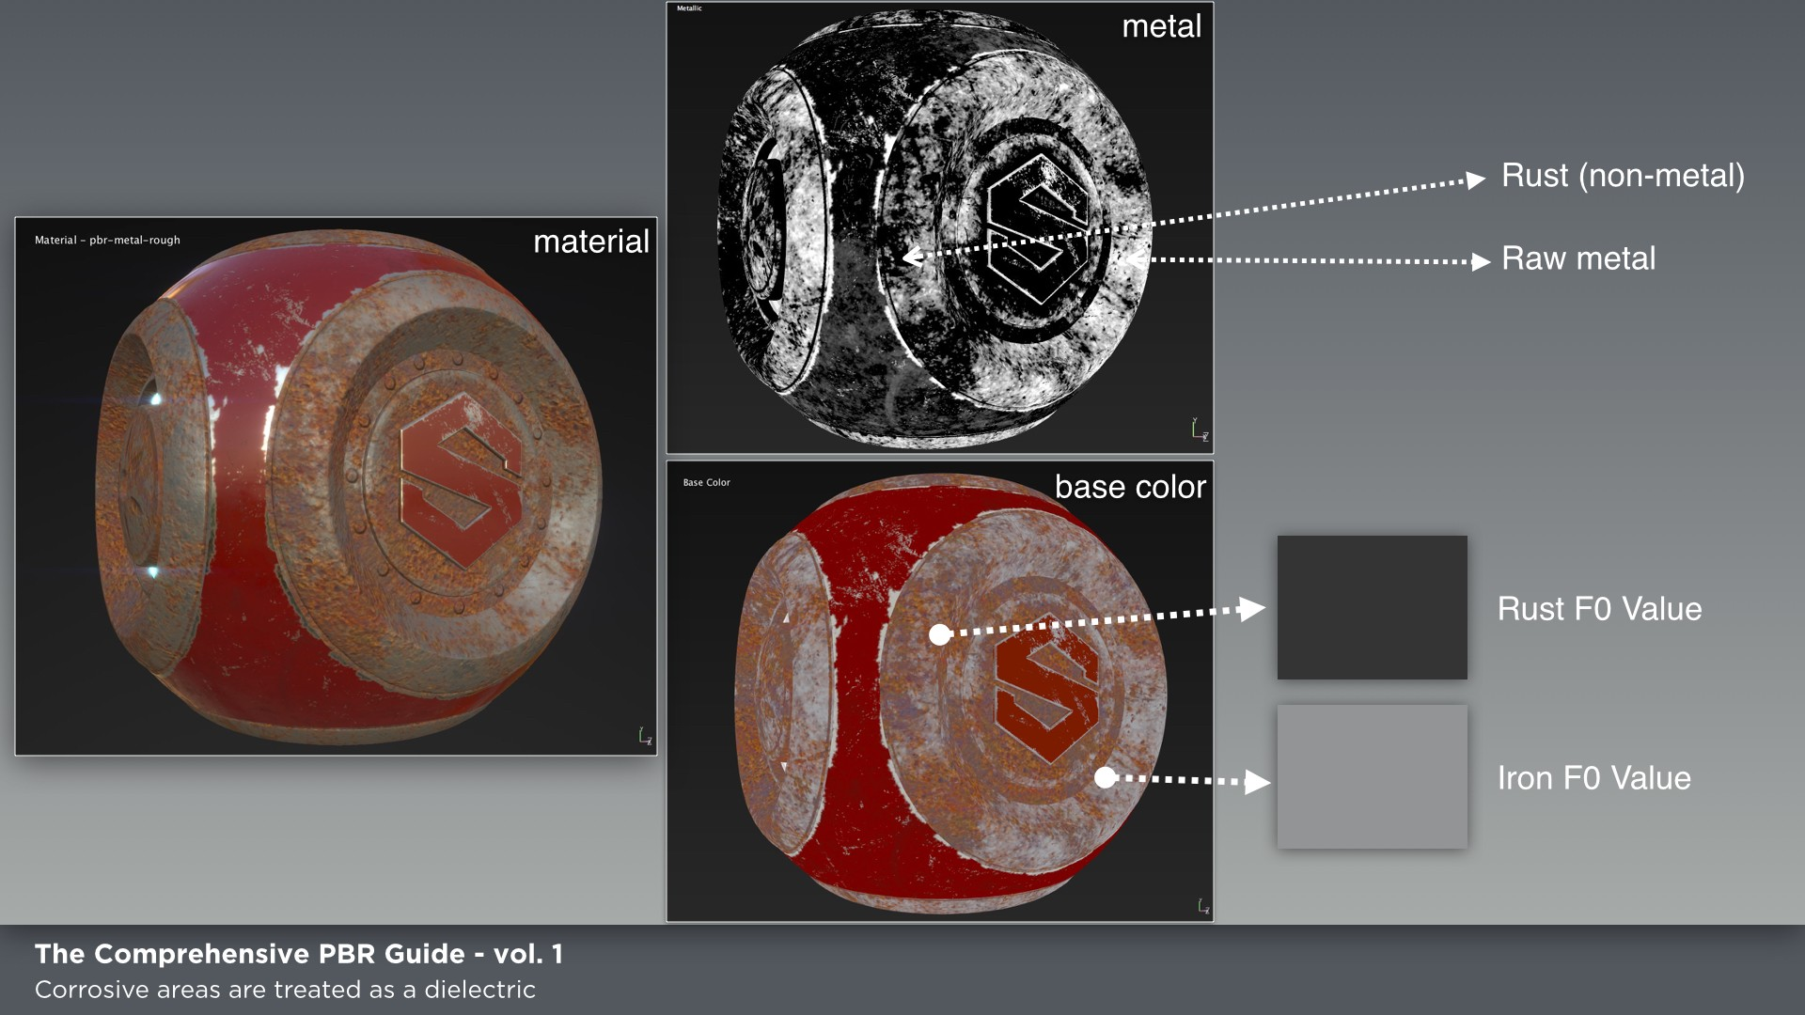

Figure 13.(图13。 )

Non-Metals.(非金属。 )

Non-metals (insulators/dielectrics) are poor conductors of electricity.(非金属（绝缘体/电介质）是电的不良导体。 ) The refracted light is scattered and/ or absorbed (often re-emerging from the surface) and thus they reflect a much smaller amount of light than metals and will have an albedo color.(非金属（绝缘体/电介质）是电的不良导体。 折射的光被散射和/或吸收（通常从表面重新出现），因此它们反射的光量比金属少得多，并且将具有反照率颜色。 ) We stated earlier that the value for common dielectrics would be around 2-5% based on the F0 as computed by the index of refraction.(颜色。 我们前面说过，普通电介质的值大约是根据折射率计算的f0的2-5%。 ) These values are contained within the linear range of 0.(这些值包含在0的线性范围内。 )017-0.(017-0。 )067 (40-75 sRGB) as shown in figure 14.(067（40-75SRGB），如图14所示。 ) With the exception of gemstones, most dielectrics will not be greater than 4%.(除宝石外，绝大部分电介质的介电常数不会超过4%。 )

.(好吧。 )

Figure 14.(图14。 )

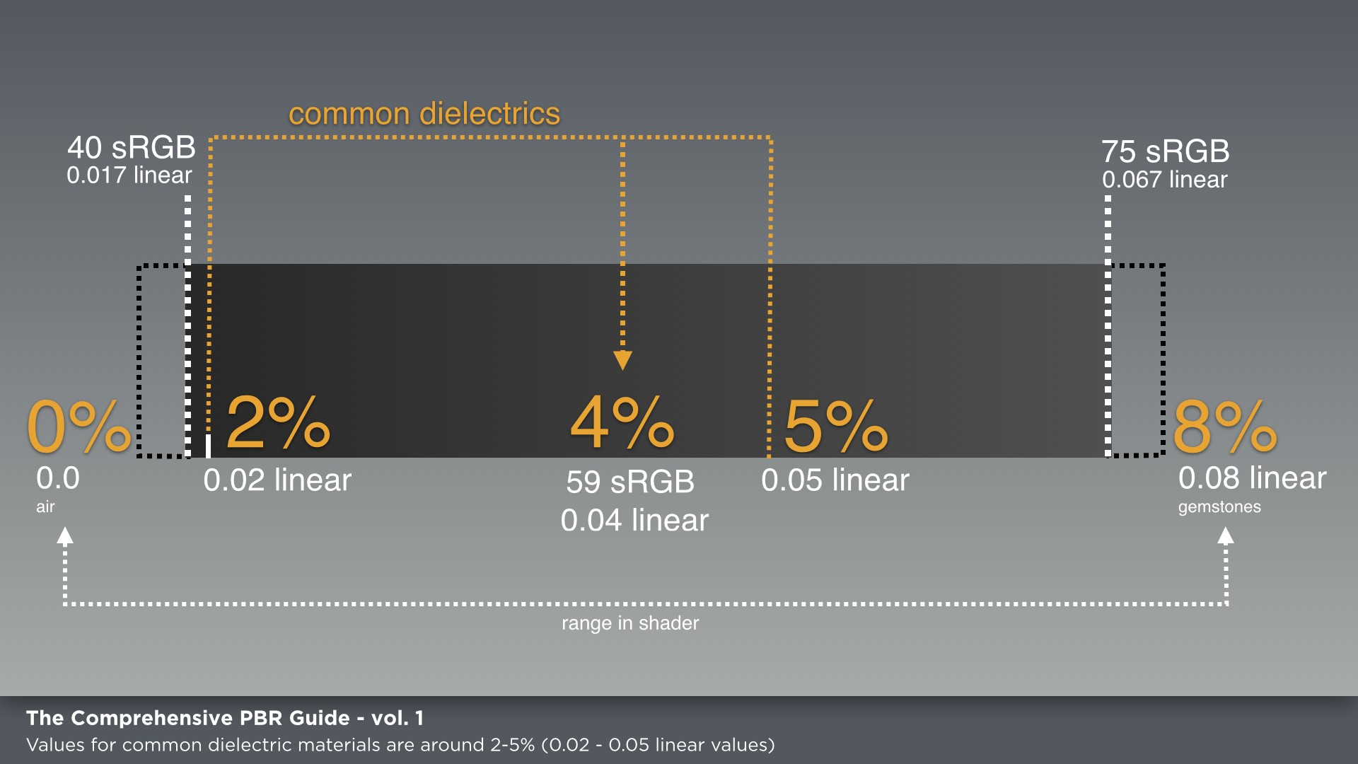

Just as with metals, we need to use real-world measured values, but it can be difficult to find an IOR for other materials that are not transparent.(就像金属一样，我们需要使用真实世界的测量值，但对于其他不透明的材料，很难找到IOR。 ) However, the value between most common dielectric materials doesn't change drastically, so we can utilize a few guidelines to follow in terms of reflectance values, which we will cover in volume two.(然而，大多数常见的介电材料之间的值并没有发生很大的变化，因此我们可以利用一些准则来遵循反射值，我们将在第二卷中介绍这些准则。 )

The value for common dielectrics is around 2-5% based on the F0 as computed by the Index of Refraction (IOR).(基于折射率(IOR)计算的f0，普通电介质的值约为2-5%。 )

**Linear Space Rendering.(线性空间绘制 )**

Linear space rendering can take up an entire article all on its own.(线性空间渲染可以单独占用整篇文章。 ) So, we won't go in-depth into the specifics.(因此，我们将不深入到细节。 ) However, the important takeaway is that computations are calculated in linear space.(然而，重要的结论是计算是在线性空间中进行的。 )

Simply put, linear space rendering provides correct math for lighting calculations.(简单地说，线性空间渲染为光照计算提供了正确的数学。 ) It’s about creating an environment that allows light to behave as it does in the real world.(这是关于创造一个环境，让光的行为，因为它在现实世界中。 ) In linear space, the gamma is 1.(在线性空间中，伽马为1。 )0.(0。 ) However, for this to look correct to our eyes, the linear gamma needs to be shifted.(然而，为了让这看起来正确，我们需要改变线性伽马。 ) Gamma-encoded space (sRGB) compensates for images that are displayed on a computer screen.(伽马编码空间（srgb）补偿显示在计算机屏幕上的图像。 ) The value of the image is adjusted for display.(调整图像的值以供显示。 )

When computing color values and performing operations on colors, all computations should be performed in linear space.(在计算颜色值和对颜色执行操作时，所有计算都应在线性空间中执行。 ) A simple way to look at it is that if an image is to be displayed in the render such as base color or diffuse, then these maps need to be set as sRGB.(一种简单的方法是，如果要在渲染中显示图像，例如基本颜色或漫射，则需要将这些地图设置为srgb。 ) What happens in Substance is that if the image is tagged as sRGB, it will be converted to linear for calculations and then set back to sRGB for display.(实际上，如果图像被标记为srgb，它将被转换为线性以进行计算，然后被设置回srgb以进行显示。 ) However, when you store mathematical values that purely denote surface attributes in a texture such as roughness or metallic, then these maps must be set as linear.(但是，当您存储纯表示纹理（如粗糙度或金属）中的表面属性的数学值时，这些映射必须设置为线性。 )

Substance handles the conversion between linear/sRGB space for inputs automatically as well gamma-correction on the computed result in the rendered viewport.(Substance自动处理输入的线性/SRGB空间之间的转换，以及在呈现的视区中对计算结果进行伽马校正。 ) As the artist, you don't need to worry about the internal working of linear-space computations and conversions in the Substance pipeline.(作为艺术家，你不需要担心物质管道中线性空间计算和转换的内部工作。 ) When using Substance materials via the Substance Integration plugin, the conversions for linear space are also handled automatically.(当通过实体集成插件使用实体材料时，线性空间的转换也会自动处理。 )

However, it’s important to understand the process, as when Substance maps are utilized as exported bitmaps and not Substance materials, you may need to manually handle the conversions depending on the renderer you are using.(然而，理解这个过程是很重要的，因为当物质图被用作导出的位图而不是物质材料时，您可能需要根据所使用的呈现器手动处理转换。 ) You need to know that base color/diffuse maps are sRGB and the rest are linear.(您需要知道基本颜色/漫射图是SRGB，其余部分是线性的。 )

When using Substance materials via the Substance Integration plugin, the conversions for linear space are also handled automatically.(当通过实体集成插件使用实体材料时，线性空间的转换也会自动处理。 )

**Key Factors.(关键因素。 )**

Now that we have explored the basic theory behind the physics, we can derive some key factors for PBR.(既然我们已经探索了物理背后的基本理论，我们可以得出一些关键因素的PBR。 )

1. Energy Conservation.(节能。 ) A reflected ray is never brighter than the value it had when it first hit the surface.(节能。 反射光线的亮度永远不会超过它第一次到达表面时的亮度。 ) Energy Conservation is handled by the shader.(节能由着色器处理。 )
2. Fresnel.(菲涅耳。 ) The BRDF is handled by the shader.(BRDF由着色器处理。 ) The F0 reflectance value has minimal change for most common dielectrics and falls within a range of 2% - 5%.(菲涅耳。 BRDF由着色器处理。 对于大多数普通电介质，f0反射率值变化最小，在2%-5%的范围内。 ) The F0 for metals is a high value ranging from 70-100%.(适用于大多数普通电介质，范围为2%-5%。 金属的F0为70-100%的高值。 )
3. Specular intensity is controlled through the BRDF, roughness or glossiness map and the F0 reflectance value.(镜面强度通过BRDF、粗糙度或光泽度图和F0反射率值来控制。 )
4. Lighting calculations are computed in linear space.(照明计算在线性空间中计算。 ) All maps that have gamma-encoded values such as base color or diffuse are usually converted by the shader to linear, but you may have to make sure that the conversion is properly done by checking the appropriate option when importing the image in your game engine or renderer.(所有具有伽玛编码值的地图（如基本颜色或漫射）通常都由着色器转换为线性，但在游戏引擎或渲染器中导入图像时，您可能必须通过选中适当的选项来确保转换正确完成。 ) Maps that describe surface attributes such as roughness, glossiness, metallic and height should be set to be interpreted as linear.(照明计算在线性空间中计算。 所有具有伽玛编码值的地图（如基本颜色或漫射）通常都由着色器转换为线性，但在游戏引擎或渲染器中导入图像时，您可能必须通过选中适当的选项来确保转换正确完成。 描述表面属性（如粗糙度、光泽度、金属性和高度）的地图应设置为线性。 )

References.(推荐信。 )

1. Physically-Based Shading at Disney Brent Burley, Walt Disney Animation Studios.(迪士尼布伦特·伯利、华特·迪士尼动画工作室基于物理的着色。 )

https://disney-animation.(https://迪士尼动画。 )s3.(第3段。 )amazonaws.(亚马逊河。 )com/library/s2012_pbs_disney_brdf_notes_v2.(com/library/s2012_pbs_disney_brdf_notes_v2。 )pdf.(pdf。 )

1. Microfacet Models for Refraction through Rough Surfaces [http://www.(“http://www.cs.cornell.edu/~srm/publications/egsr07-btdf.pdf”http://www.cs.cornell.edu/~srm/publications/egsr07-btdf.pdf“http://www。 )cs.(政务司司长。 )cornell.(康奈尔。 )edu/~srm/publications/EGSR07-btdf.(EDU/~SRM/Publications/EGSR07-BTDF。 )pdf.(pdf。 )](http://www.(通过粗糙表面折射的微面模型超链接)
2. Feeding a Physically-Based Shading Model by Sebastien Lagarde http://seblagarde.(超链接“http://seblagarde.wordpress.com/2011/08/17/feed-a-physical-based-light-mode/”http://seblagarde。 )wordpress.(Wordpress。 )com/2011/08/17/feeding-a-physical-based-lighting-mode/.(COM/2011/08/17/FEED-A-基于物理的照明模式/。 )
3. An Introduction to BRDF Models by Daniël Jimenez Kwast [http://hmi.(超链接“http://hmi.ewi.utwente.nl/verslagen/capita-selecta/cs-jimenez-kwast-daniel。pdf”http://hmi。 )ewi.(伊威。 )utwente.(乌特文特。 )nl/verslagen/capita-selecta/CS-Jimenez-Kwast-Daniel.(NL/Verslagen/Capita-Selecta/CS-Jimenez-Kwast-Daniel。 )pdf.(pdf。 )](http://hmi.(DaniëlJimenezKwast超链接介绍BRDF模型)

Allegorithmic develops the new generation of 3D texturing software: Substance Painter, Substance Designer and Bitmap2Material.(Allegalithmic开发了新一代的三维纹理绘制软件:实体绘制器、实体设计器和BitMap2Material。 ) With most AAA game studios using these tools, Substance has become the standard for creating next-generation PBR (Physically Based Rendering) assets.(随着大多数AAA游戏工作室使用这些工具，实体已经成为创建下一代PBR（基于物理的渲染）资产的标准。 )

For more information on Substance, please visit our website at.(欲了解更多关于实质内容的信息，请访问我们的网站。 )

[**www.(超链接“http://allegalithmic.com/”www。 )allegorithmic.(寓言式的。 )com.(在网上。 )**](http://allegorithmic.(超链接)

